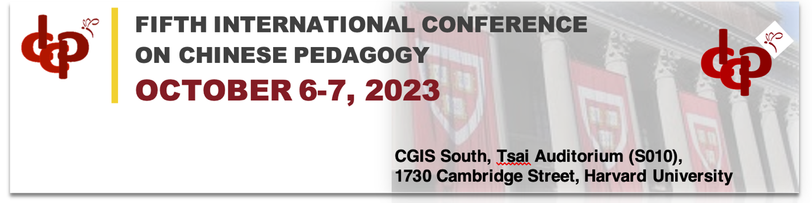

2023 Harvard University 5th International Conference on Chinese Pedagogy
2023年第五届哈佛国际中文教学研讨会

Dear Friends and Colleagues,

The 5th Harvard International Conference on Chinese Pedagogy (Harvard ICCP) will be held on October 6-7, 2023 fully in-person at Harvard University in Cambridge, Massachusetts. The theme of this session of the ICCP will be: Leading change and re-engagement. You are cordially invited to attend the conference to interact, share and discuss new currents and trends in Chinese language pedagogy with scholars from North America and across the globe.

In addition to talks from our guest speakers, we welcome proposals for empirical research-based presentations. We also encourage graduate students and young scholars to submit proposals. The conference aims to include, but is not limited to, the following areas:

- Post-pandemic TCFL （后疫情时代的对外汉语教学）
- Remote and Hybrid Class Design （远程及混合课堂设计）
- Technology and Language Teaching（科技辅助教学）
- Second Language Acquisition: Theory and Practice （二语习得理论与实践）
- Content-based Language Teaching（内容本位语言教学）
- Literacy and Communication in TCFL （对外汉语教学中的听说读写）
- Corpus-based Language Teaching （语料库与语言教学）
- Language Teaching Testing and Assessment （语言教学测试与评估）

All who wish to present at the conference must fill out the ICCP Reply Form and submit your abstract at the end of the online form. (400 words maximum, either in English or Chinese) no later than December 4, 2022. We will notify you of the result of committee review by January 23, 2023. Accepted individual proposals will be grouped into panels according to theme. If accepted, we ask that you submit the slides to be used for your 15-minute talk by September 22, 2023.

The Conference will take place over the course of two days: Friday (October 6th) 3:30 pm - 6:00 pm and Saturday (October 7th) 9:00 am - 6:00 pm.

We are pleased to offer presenters free admittance to the conference. In addition, the lunch and reception on Saturday (October 7th) will be provided free of charge to participants. Due to limited funding, we are unable to cover the travel or lodging expenses, but we encourage you to reach out to your home institution for additional funding.

In order to streamline the Conference preparation logistics, we ask that all who wish to attend the conference submit a registration form on our conference website by September 22, 2023 (online registration might be closed earlier than this date if registered participants reach our capacity limit). The admittance rates for the conference are as follows. Our early bird rates will only be available for those who register online before April 23, 2023. We strongly encourage all participants to register as soon as possible.

 | Registration Fee
Early Bird Student | $30
Student | $50
Early Bird Regular | $50
Regular | $70

For more information, please visit our conference website: (website link).

If you have any questions or concerns, please feel free to contact us at harvardiccp@gmail.com.

The Harvard ICCP Committee
September, 2022

